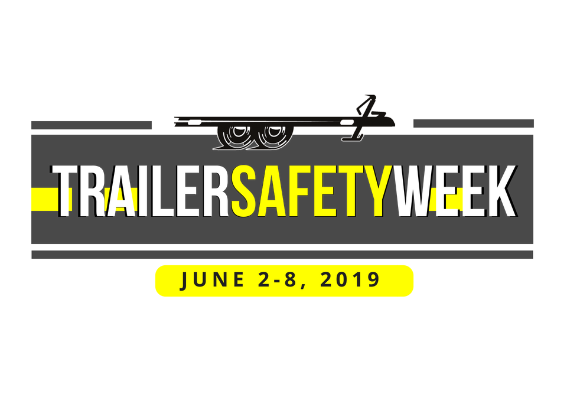
FOR IMMEDIATE RELEASE Contact: [CONTACT NAME]
[COMPANY] [PHONE NUMBER] [EMAIL ADDRESS]

[HOST COMPANY] to Host Trailer Safety Week Event on [DATE] for [CITY]

(CITY, STATE – DATE) In observation of Trailer Safety Week 2019, [COMPANY NAME] will host an onsite educational event focusing on safe trailer towing on [DATE]. The company is proud to join the fight to improve the safety of America’s roads and highways this week through education efforts.

The Mission of Trailer Safety Week is “To improve the safety of the nation’s roadways by raising trailer safety awareness through education of end-users, dealers and manufacturers on safe trailering practices.” Although trailer safety is important to focus on 365 days a year, Trailer Safety Week will officially take place June 2-8, 2019. The events are meant for anyone who is curious about learning more about the importance of trailer safety. Audiences include trailer dealers, manufacturers, fleet managers and end-users.

Trailer Safety Week is an annual event that features two distinct parts: onsite facility events hosted at
NATM verified compliant trailer manufacturers and a nation-wide marketing of printed and online resources to trailer dealers across the nation. For onsite events, trailer dealers, consumers, law enforcement, public officials, and other interested parties are invited to attend, tour the facilities and learn about the educational resources that are available to trailer users.

The onsite event will include trailer safety education as well as a review of available resources such as www.TrailerSafetyWeek.com, an introduction to the host company and the role the company has taken in helping to ensure roadway safety, and tips on identifying trailer built in compliance with Federal Motor Vehicle Safety Standards. Attendees will be able to tour the company’s facility to get a better understanding of the trailer manufacturing process.

About [Company]
[Insert company boilerplate here and include link to website in last sentence.] For more information on Trailer Safety Week, visit www.TrailerSafetyWeek.com. For more information about the National Association of Trailer Manufacturers and the compliance verification program visit www.NATM.com.

